**ONLINE COFFEE SHOP**

**Main objective**

* To develop an online coffee ordering app.

**Specific objectives**

* Gather system requirements
* Perform analysis from the gathered requirements
* Design the system
* Implement the modules
* Payment system
* Data management and archiving
* Test the code
* Deploy and maintain the system

**UML DIAGRAMS SYMBOLS**

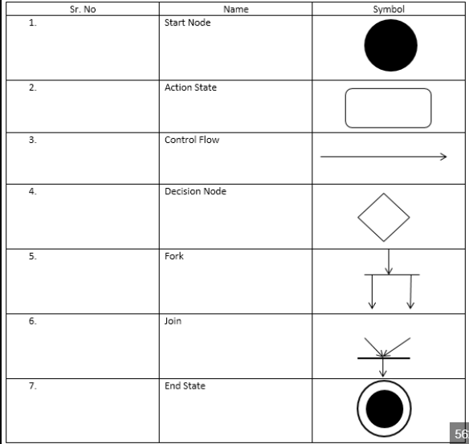

08/05/2023

**Software Engineering Methodology**

* Reuse-oriented software engineering

**System Use cases**

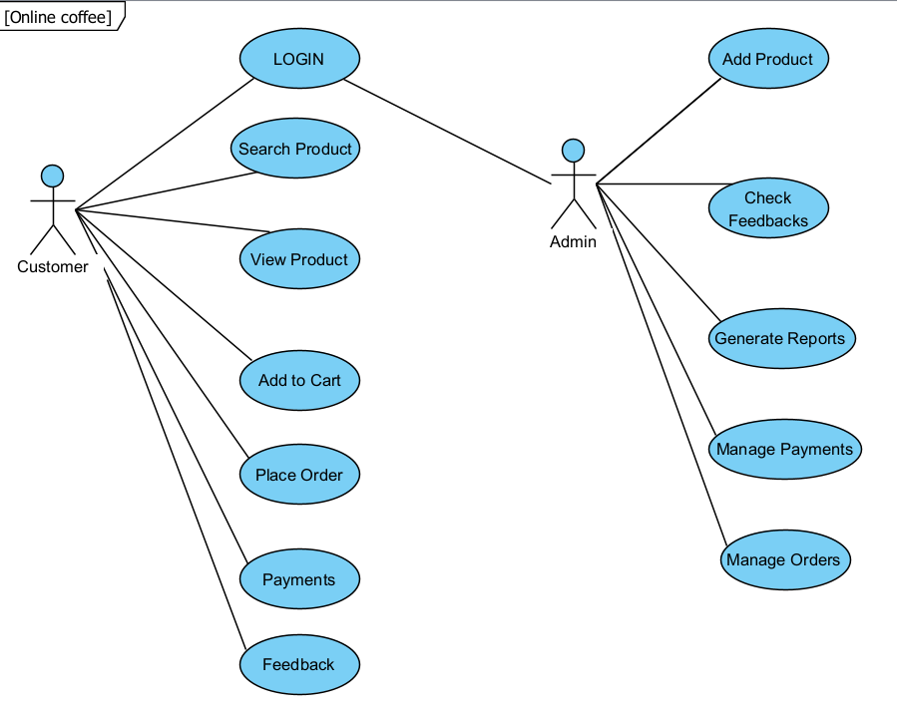

1. **Context models**

**<<system>>**

**ORDERING SYSTEM**

**<<system>>**

**CUSTOMER SERVICE**

**<<system>>**

**PAYMENT SYSTEM**

**<<system>>**

**DELIVERY SYSTEM**

**<<system>>**

**INVENTORY STORAGE**

**Warehouse**

**Customer Service**

**Accounting**

**Customer**

**Credit Card Authorization Company**

**Credit Request**

**Complaints**

**Corrected orders**

**Payment Receipts**

**Orders**

**Payments**

**Order Status**

**Complaints**

1. **Interaction models**
2. **Use case involving the role Admin**

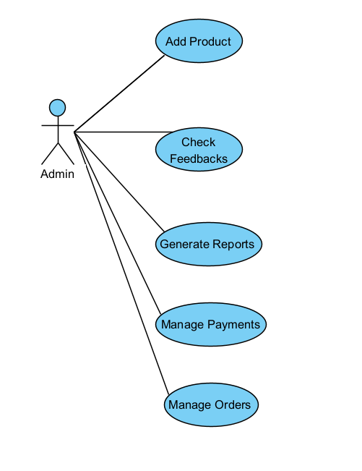

1. **Use case involving a User**

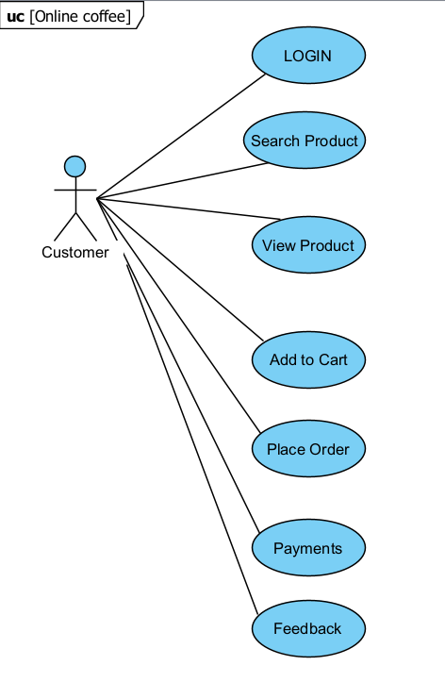

1. **Structural Models**

**Classes and associations in the Ordering system**

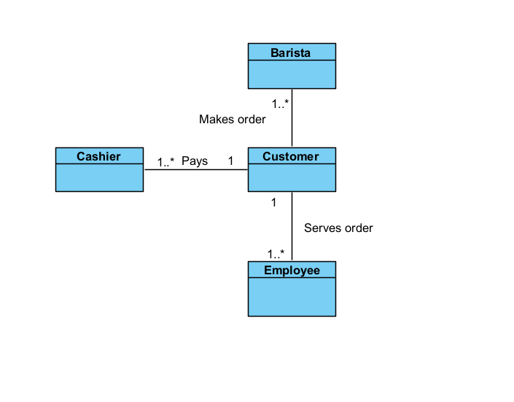

1. **Behavioural models**

**An Activity model of the ordering system (Data Driven model of the User’s side)**

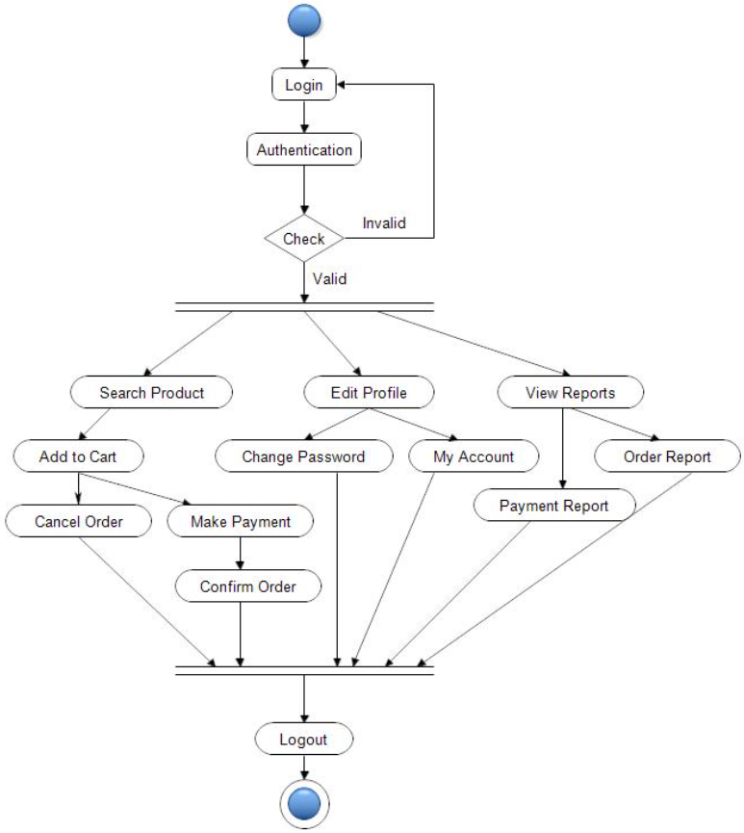

**An Activity model for the Admin’s side (Data Driven)**

